Summary of Chapters 1, 2, 3, and 4 AGNEY PRASEED

We observe the behaviour of the vehicles in the presence of a single source of stimulation.

Chapter 1:

In chapter 1, we are introduced to a simple vehicle which has just one sensor and a motor. The sensor is directly connected to the motor. When our vechicle is exposed to a heat source, it will move towards it. Here we see a linear relationship between our vechicle spped and the heat source as the temperature of source rises our vechicle will acelelrate more towards it.

We get to simulate a purely forward motion with speed that varies on the environment. In warm regions the motor receives stronger input and hence the vechicle moves faster and in cold regiosn the vechicle is slow.

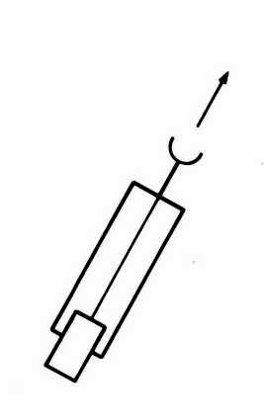

The author talks about this behaviour as a simplified form of Aristotelian physics, that a moving object's speed is proportional to the applied force. He also talks about friction, on earth it is unavoidable and causes the vehicle to slow down when the temperature decreases.

Friction can make the vehicle stop in cold regions where friction outweighs the motor’s force. It can cause the movement of the vehicle to be irregularand cause it to deviate from the straight path towards the source, this motion resembles a Brownian motion but it is still dependent on the source.

If we picture our Vehicle 1 to be swimming in a pool, we can observe from its motion that it is restless, dislikes warm water. The author describes this it to be alive, a take on human perception and attribution. To an external observer, such behaviour might appear purposeful or emotional but the vehicle we have is a completelydeterministic machine with nocognition, no goals, and no memory. Its behaviour, though appearing purposive or emotional, is simply the result of a mechanicalstimulus-response relationship.

The key idea of this chapter is that “Complex, seemingly intelligent behavior can emerge from simple mechanisms and Observers (humans) project intention onto systems that merely follow physical laws.”

Chapter 2 :

The author introduces Vehicle 2 that has two sensors and two motors. Using this configuration we can make three kinds of vehicles. Here too the concepts of linear dependence hold the more the sensors receive heat the faster the motor goes.

The three configurations possible are (2a) each sensor to the motor on the same side, (2b) each sensor to the motor on the opposite side, (2c) both sensors to both motors.

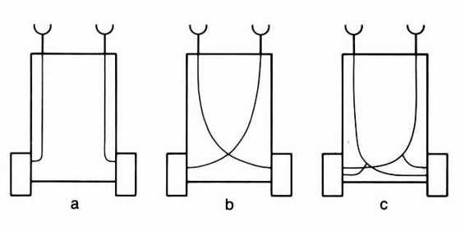

In the first case, each sensor controls the motor on the same side. This connection is called Ipsilateral connection. If the source is present to one side, the sensor near it will be excited more and hence the motor will move faster towards it while the other side will be slower, due to this our vehicle will turn away from the source. An observer can label this behaviour of the vehicle as “coward”. The vehicle becomes restless in the vicinity of source and tends to avoid it, escaping until it safely reaches a place where the influence of the source is scarcely felt.

In the second case, each sensor controls the motor on the opposite side. This is called Contralateral connection. When the source is to one side, it will increase the force of sensor that is close to the source towards it and causing the vehicle to turn toward the source. The vehicle will ultimately hit the source. An observer can label this behavior as aggressive. The vehicle ultimately collides with the source unless a precise and uninterrupted perturbation occurs.

We see that both vehicles 2a and 2b dislike the source, one tries to avoid while other wants to destroy the source.

This demonstrates how simple changes in internal wiring can give rise to distinctly complex and seemingly intentional behaviors.

Chapter 3:

A key limitation of vehicle 1 and 2 is that their behaviour is entirely reactive and unidirectional. It does not differentiate between helpful or harmful signals. In human or animal nervous systems, there are both excitatory and inhibitory signals.

We introduce connections between the sensors and the motors, switching the sign of the influence from positive to negative. This will let the motor slow down when the corresponding sensor is activated. Sensor activation leads to motor deceleration and inactivity allows full motor speed.

We can make two variants, one with straight and one with crossed connection. Both will slow down in the presence of a strong stimulus and race where the stimulus is weak. They will therefore spend more time in the vicinity of the source than away from it. They will come to rest in the immediate vicinity of the source. These new vehicles are attracted to stimuli but respond passively by slowing down and eventually stopping near them.

In the case of vehicle with the Straight Connections (3a) it will come to rest facing the source. Approaching the source, it will orient toward it, the sensor closer to the source receives more input, thereby slowing its corresponding motor more than the other. This causes the vehicle to turn toward the source. This vehicle seems to seek and settle peacefully near the source, we observe a “calmed” behaviour.

In the second case (3b), the vehicle with Crossed Connection, it will come to rest facing away from the source. The sensor closer to the source slows the opposite motor, causing the vehicle to turn away from the source as it approaches. It comes to rest in but facing away from the source. But it may not stay in the same place as even a tiny disturbance will cause it to drift away. The source’s influence weakens, and the motors begin to accelerate again, carrying it further away. Although it slows near the source, it does not remain so we observe a “nervous” behaviour from our vehicle.

Both vehicles LIKES the source, but 3a LOVES it in a permanent way, staying close by in quiet admiration from the time it spots the source to all future time. Vehicle 3b, on the other hand, is an EXPLORER. It likes the nearby source all right, but keeps an eye open for other, perhaps stronger sources, which it will sail to, given a chance, to find a more permanent and gratifying appeasement.

Vehicle 3c is a more advanced and integrated version it combines multiple types of sensor-motor connections, creating a more complex behaviour. It is equipped with four pairs of sensors, each tuned to a different environmental quality, say light, temperature, oxygen concentration, and amount of organic matter. Each sensor pair is connected to the motors using a different type of wiring. we connect the first pair to the motors with uncrossed excitatory connections, as in Vehicle 2a, the second pair with crossed excitatory connections, as in Vehicle 2b and the third and the fourth pairs with inhibitory connections, crossed and uncrossed, as in Vehicles 3b and 3a. Our vehicle now has the following characteristics It dislikes high temperature, turns away from hot places, and at the same time seems to dislike light bulbs with even greater passion, since it turns toward them and destroys them. On the other hand, it seems to prefer a well-oxygenated environment and one containing many organic molecules, since it spends much of its time in such places. But it is in the habit of moving elsewhere when the supply of either organic matter or (especially) oxygen is low.

Our Vehicle no longer defined by a single behavioural trait. It has VALUES and KNOWLEDGE of the environment. Our vehicle to an observer seems to exhibit intelligent or knowledgeable behavior but the author strongly states that it is just an illusion, Knowledge, properly defined, requires a flow of information from the environment into a system in a way that modifies its internal state or understanding. In Vehicle 3c, the behavior emerges purely from predefined mechanical connections (sensor-to-motor), without any internal representation or learning. Even without real knowledge, Vehicle 3c can express a huge variety of behaviors, depending on the type of sensors, pattern of their connections.

This chapter shows us the power of emergent behaviour, even systems without any form of learning (true knowledge acquisition) can act in surprisingly lifelike and differentiated ways.

Chapter 4:

Until now our vehicles had simple monotonic connections, in Vehicle 4 author introduces nonmonotonic sensor-to-motor connections. Motor speed increases with sensor stimulation only up to a certain point, after this peak, further stimulation causes motor speed to decline.

In vehicle 4a when approaches a source, avoids it if the stimulus becomes too strong. It may orbit around a source at a stable distance where the stimulus intensity aligns with the peak response. It can demonstrate cyclical patterns, due to dynamic balancing between attraction and aversion. These behaviours appear to be governed by “INSTINCTS”.

In Vehicle 4a, its responses are still governed by smooth, continuous functions. Vehicle 4b is made to approximate more realistic, lifelike patterns, the model is extended to include discontinuities in the sensor-motor connection. The motor does not activate until the stimulus exceeds a certain threshold. Once past the threshold, motor activity might jump to a fixed level or increase smoothly from a minimum. The vehicle may not react to a stimulus until it exceeds a certain threshold. This delay can appear as hesitation, contemplation, or deliberation. This creates an illusion of “WILL”.

While the internal architecture of Vehicle 4b is entirely mechanical, its external behaviour evokes psychological constructs like free will, motivation, and resolve. The author empathises that the use of Thresholds and discontinuities alone can produce artificial agents that can create anthropomorphic interactions.